

**PHYSICAL THERAPY ASSESSMENT**

**Name: Tanvi Monoot Date:**

**Age: 13/female**

**Sports: Badminton**

**On observation:**

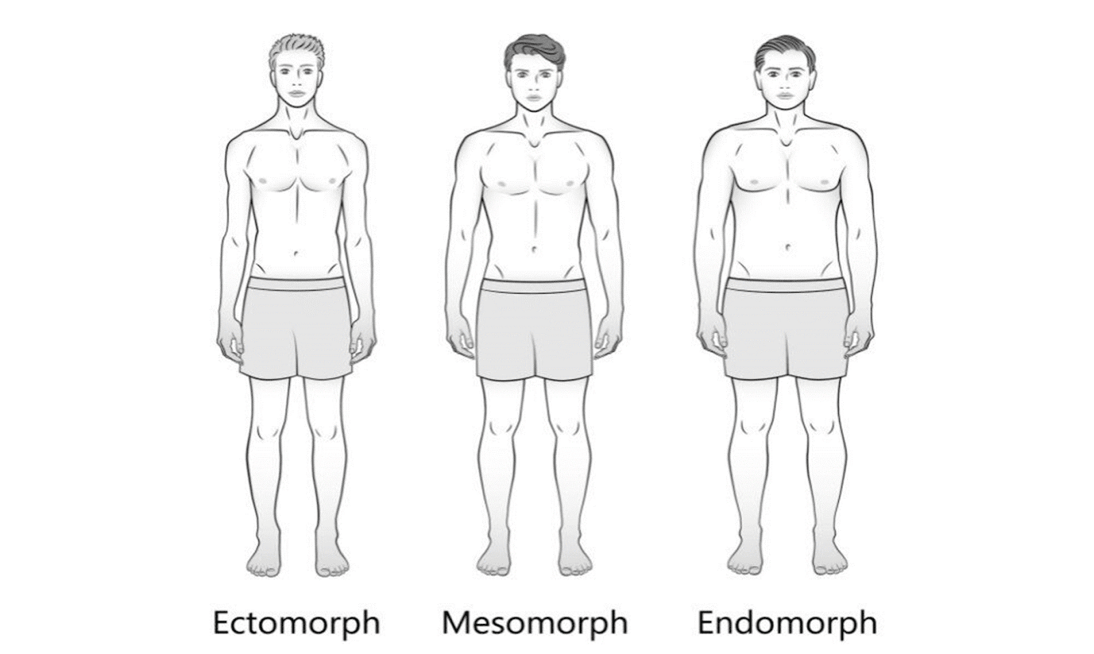

* **Body type :ectomorph**
* **Posture: Normal**
* **Joint alignment: N**

* **Limb length: Normal**

**Chief Complaints :**

* Pain in left ankle lateral side while dorsiflexion and plantar flexion and inversion post lateral malleolar fracture

**Past history: Lateral malleolar fracture (2 wks back ) after fall**

**On assessment : - Stiffness in ankle joint post fracture**

**Reduced Strength in Plantar flexors and inverters**

**Diagnosis:**

**Ankle joint stiffness post fracture**

**Treatment:**

* **Mobilization**
* **Strengthening for ankle and intrinsic foot muscles**
* **Overall lower limb and core strengthening**
* **Balance training**
* **Impact Training**

**Recommendations: 3 SESSION /PER WEEK**