

**PHYSICAL THERAPY ASSESSMENT**

**Name: Paulose Date: 26.6.24**

**Age: 75/M**

**On observation:**

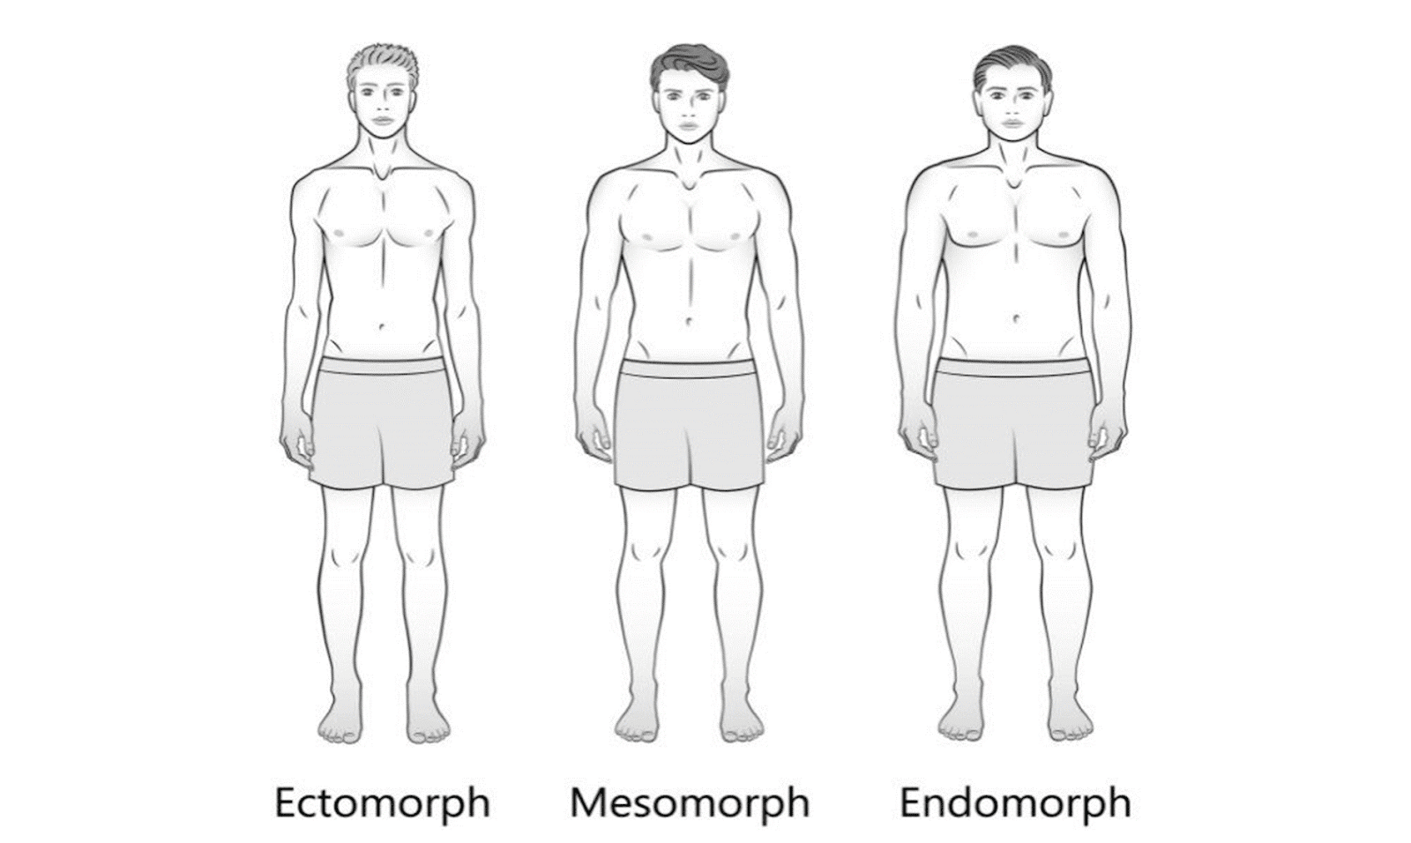

**Chief Complaints : Can not lift hands beyond 90 degrees , difficulty in training . radiating pain from neck to bilateral hands**

**Past history: Frozen Shoulder since 3 years**

**On assessment: Capsular restriction pattern**

**ER . IR , Flexion and abduction restricted**

**ROM : Flexion : 70**

**Abduction: 80**

**ER: 20**

**DIAGNOSIS: Bilateral Periarthritis Shoulder**

**RECOMMENDATION :**

* **Physiotherapy for 4 weeks for STR , Pain Management , Shoulder Mobs**
* **Dry needling if required**