|  |
| --- |
| Name : **Mrs.Radha** |
| Age : **63 , Female** |
| Clinical : **Sciatic pain** |

**Assessment Date: 9/03/2024**

**Customized Plan – (16 Physiotherapy + 2 Mind relaxation)**

**Total - 18 sessions - *9,000/-***

**PHYSIOTHERAPY CONSULTATION FORM**

**On observation**:

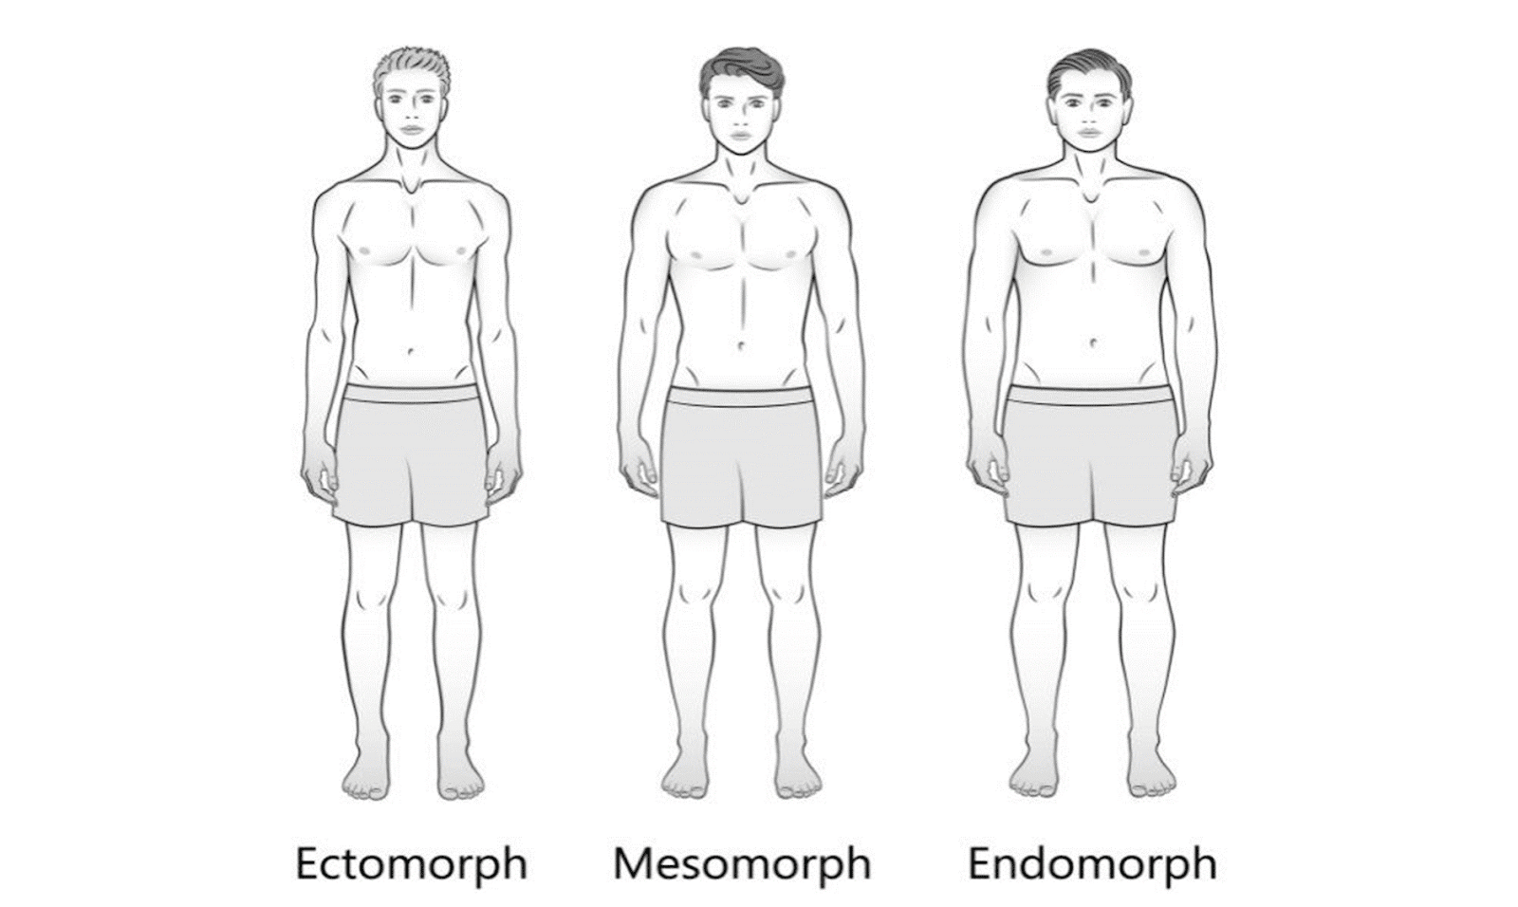

* Body type :endomorph
* Posture: normal
* Joint alignment: Normal
* Limb length: -

**Chief complaints:**

Patient has complaint of pain in LOW back .she has pain over the spine bend movement and radiating pain

**Past history:**

8 months before patient had back pain.

**Pain history**

Side: right

Site: low back

**Onset:** gradual

**Duration:** 6 month

**Aggravating factor:** spine bend movement

**Relieving factor:** rest

**VAS: 9/10**

**On palpation**

Tenderness: normal

Warmth: present

**On examination -**ROM: normal

**Diagnosis**: Sciatic pain

**Treatment plan:**

* Stretching exercise.
* Manual releasing, IFT.

**Physiotherapy treatment session details:**

**11/03/2024**

* Pain scale 9/10
* Pain management IFT
* Manual muscle releasing
* Stretching

12/03/2024

* Pain scale 8/10
* Pain management IFT
* Manual muscle releasing
* Stretching

13/03/2024

* Pain scale 8/10
* Pain management IFT
* Manual muscle releasing
* Stretching

14/03/2024

* Pain scale 6/10
* Pain management IFT
* Manual muscle releasing
* Stretching
* Strengthen exercise.

15/03/2024

* Pain scale 5/10
* Pain management IFT
* Manual muscle releasing
* Stretching
* Strengthen exercise.

16/03/2024

* Pain scale 3/10
* Pain management IFT
* Manual muscle releasing
* Stretching
* Strengthen exercise.

18/03/2024

* Pain scale 2/10
* Pain management IFT
* Manual muscle releasing
* Stretching
* Strengthen exercise.

20/03/2024

* Pain scale 1/10
* Pain management IFT
* Manual muscle releasing
* Stretching
* Strengthen exercise.

21/03/2024

* Pain scale 0
* Pain management IFT
* Manual muscle releasing
* Stretching
* Strengthen exercise.

29/03/2024

* Pain scale 4/10
* Pain management IFT for left shoulder
* Manual muscle releasing

30/03/2024

* Pain scale 3/10
* Pain management IFT for left shoulder
* Manual muscle releasing