

**PHYSICAL THERAPY ASSESSMENT**

**Name: Hemsuta.B Date: 22-6-24**

**Age: 11/F**

**Sports:Shooting**

**On observation:**

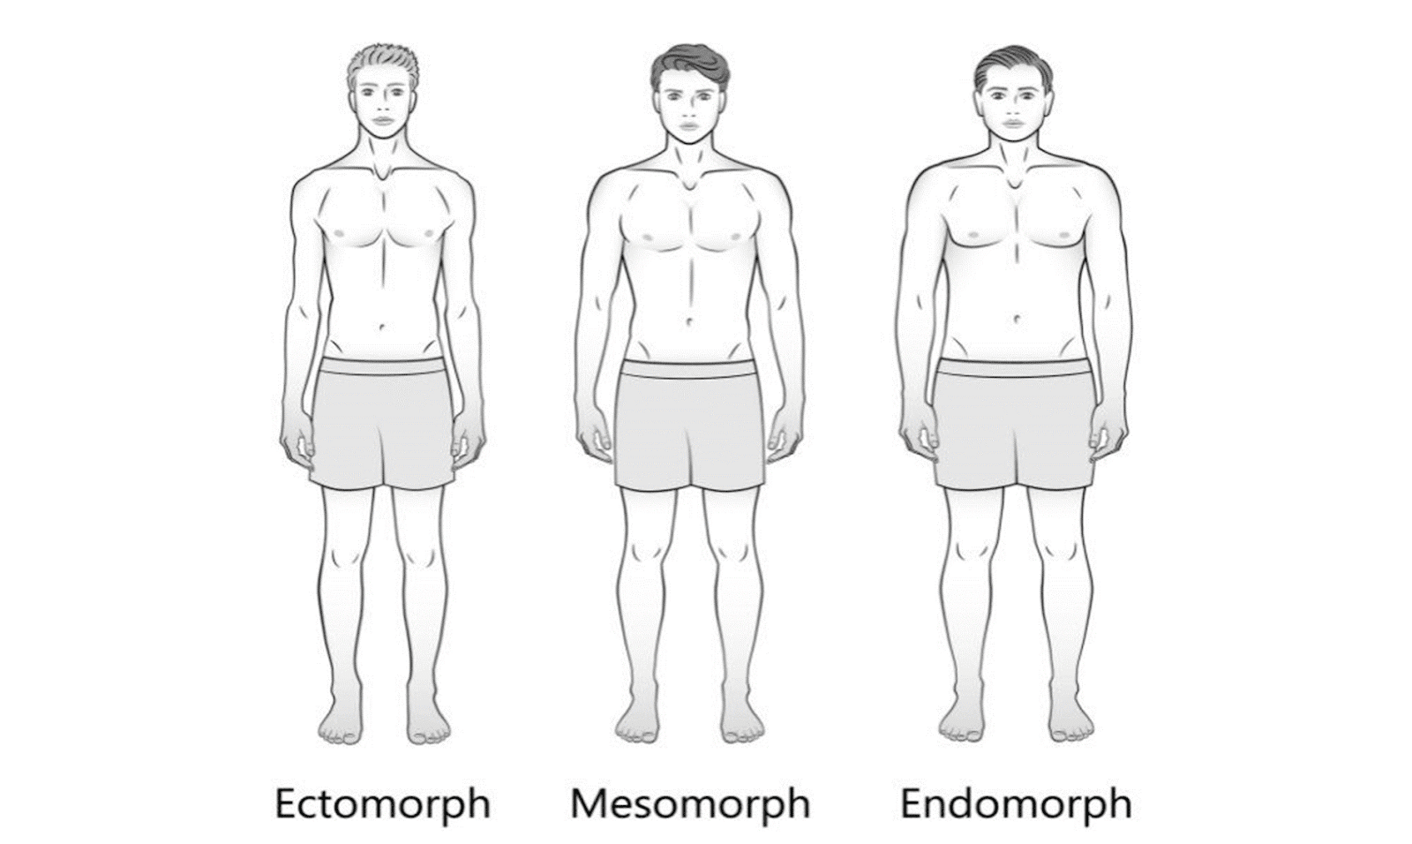

* **Body type : Mesomorph**
* **Posture: Good**
* **Joint alignment:Good**
* **Limb length: N/R**

**Chief Complaints : Ankle Pain**

**Upper Abdominal pain while shooting**

**Past history: N/R**

**On assessment:**

**Reduced Ankle mobility**

**Calf myofascial tightness**

**DIAGNOSIS : Psychological pain due to fear**

**MFPS( gastroc soleus)**

**Recommendations:**

**Physiotherapy session twice a week for :**

1. **Ankle Mobilization**
2. **MFR for calf muscles**
3. **Foot Strengthening**

**Follow up with Psychologist for : 1. Fear of losing**

**2. Lack of attention at home**