

**PHYSICAL THERAPY ASSESSMENT**

**Name: Atharv Date: 22-6-24**

**Age: 12/M**

**Sports:Shooting**

**On observation:**

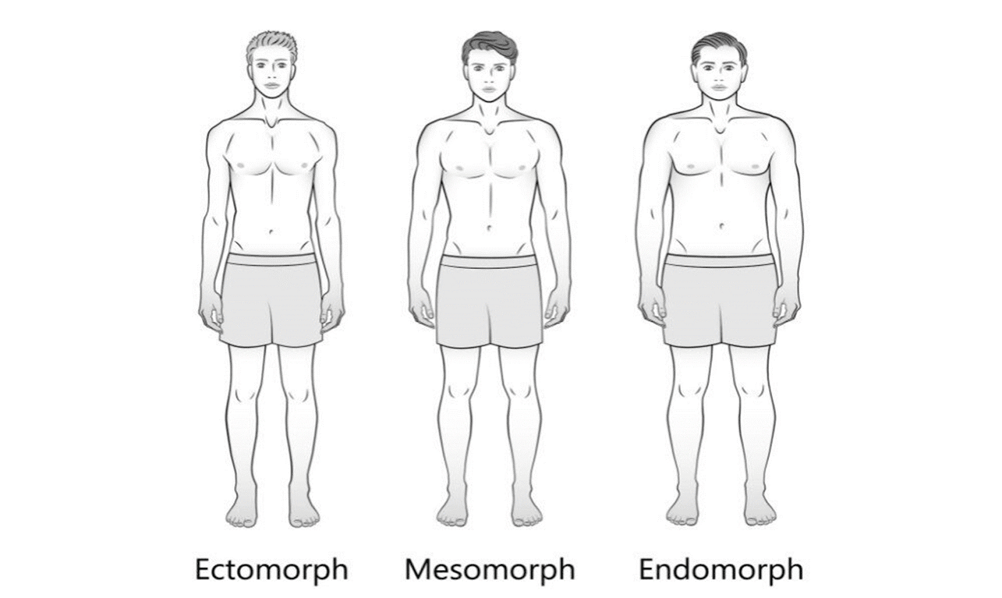

* **Body type : Mesomorph**
* **Posture: Good**
* **Joint alignment:Good**
* **Limb length: N/R**

**Chief Complaints : Pain on medial side of wrist Rt, B/L knee pain after standing long.**

**Past history: twist injury in right wrist 4 weeks back**

**On assessment:**

**Tenderness over ulnar side of wrist .**

**Piano key test : positive**

**DIAGNOSIS : TFCC Strain**

**Recommendations:**

**Physiotherapy session twice a week for :**

1. **UST**
2. **MFR for forearm muscles**
3. **Wrist Strengthening**

**Follow up with Sn C**