

**PHYSICAL THERAPY ASSESSMENT**

**Name: Adithya Bankapur Date: 22-6-24**

**Age: 43/M**

**Sports:Shooting and Badminton**

**On observation:**

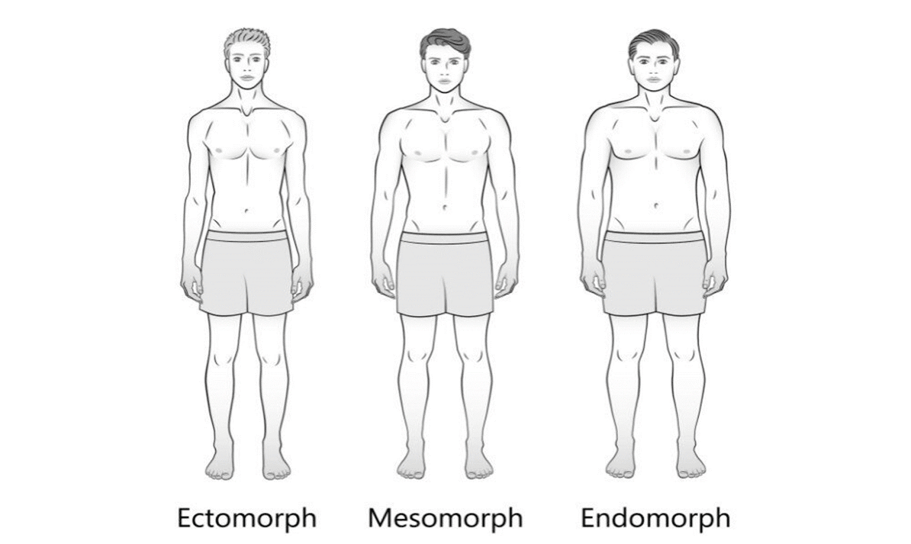

* **Body type : Mesomorph**
* **Posture: Ant. pelvic tilt**
* **Joint alignment:Good**
* **Limb length: N/R**

**Chief Complaints : On and off lower back pain**

**Past history: H/O olecranon bursitis 1.5 yrs back**

**On assessment:**

**Rt side FABERS - Positive**

**Reduced SI joint Mobility**

**DIAGNOSIS : Mild SI joint dysfunction ( RT )**

**Recommendations:**

**Physiotherapy session twice a week for :**

1. **SI joint Mobilization**
2. **Pelvis Mobility Exercises**
3. **Rotator Cuff Strengthening**

**Follow up with Sn C**